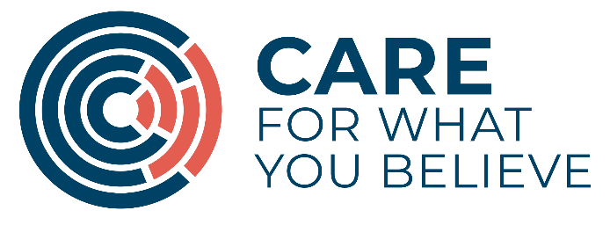

EQUAL OPPORTUNITIES FORM

CARE recognises the need for fair and consistent recruitment and selection procedures that ensure that no job applicant, employee or volunteer is placed at a disadvantage by conditions or requirements that cannot be justified on the basis of the needs of a particular role.

The data you provide will be used for monitoring purposes only in order to help us measure changes in applicant demographics and identify where further action is needed. All information provided will be treated in the strictest confidence and will not be used as a selection tool.

By completing and returning this form, you consent to the charity obtaining, keeping and using this personal data for monitoring purposes. Answering the questions below is voluntary but your co-operation would be of great value.

Please provide information on the following

Where did you see/hear of this vacancy?

Date of Birth ..../…../……

Gender

Female Male

Marital Status

Married Single

Divorced Widowed

I have a disability that I would like CARE to know about:

Yes No

If yes, please give details and indicate whether this disability may affect your ability to carry out any aspects of this job and any reasonable adjustments that we could make.

………………………………………………………………………………………………………………………………………………………………………………………………………………………………………………………………………………...................................................................................................................................

EQUAL OPPPORTUNITIES FORM CONTINUED

Do you require any assistance to attend and participate in an interview?

Yes No

If yes, please give details

……………………………………………………………………………………………………………………………………………………………………………………………………....................................................…………………

Nationality:

I would describe my ethnic origin as:

…………………………………

Thank you for your co-operation in providing us with this information.

CARE is a company limited by guarantee registered in England and Wales at 53 Romney Street, London, SW1P 3RF, Company No: 3481417, Charity No: 1066963, Scottish Charity No: SC038911

